

# Budget at a Glance

# The Growth Budget

**Hon Nicola Willis**

**Minister of Finance**

**22 May 2025**

# Budget 2025 delivers

|  |  |
| --- | --- |
| **1** | **A new tax incentive – Investment Boost – to encourage business investment that lifts wages and grows the economy.** |
| **2** | **Additional investment in health, education, law and order, and other frontline public services.** |
| **3** | **KiwiSaver changes to support Kiwis to save more for their first home and retirement, and to make the scheme more fiscally sustainable.** |
| **4** | **Funding to boost Defence Force capability and respond to a more challenging global environment.** |
| **5** | **New infrastructure, including a $1 billion investment in hospitals and a more than $700 million investment in schools.** |
| **6** | **Targeted cost-of-living support for low- to middle‑income families and other groups.** |

Unless otherwise stated, funding in this document refers to operating funding over the forecast period, plus capital funding.

# Budget 2025 package

Budget 2025 includes new spending, savings and reprioritisation of resources to frontline services, all within an **operating allowance of $1.3 billion per annum.** This is the lowest allowance in a decade and ensures the Government remains on track to get its books back in order.

|  |  |
| --- | --- |
| **Budget 2025 package** | **Average annual operating $ million (net of reprioritisation)** |
| Health | 1,752 |
| Investment Boost | 1,660 |
| Defence and foreign affairs | 477 |
| Education | 381 |
| Law and order | 263 |
| Disability Support Services | 255 |
| Business, science and innovation | 130 |
| Social investment | 69 |
| Transport | 64 |
| Other new spending | 1,199 |
| Additional revenue and savings | (4,911) |
| **Total Budget 2025** | **1,338** |

Totals do not sum due to rounding.

Budget 2025 also provides **$6.8 billion of new capital investment**, within a net capital allowance of $4.0 billion. This includes:

* Over $1 billion for Health.
* $734 million for Education.
* Over $1 billion for Defence (plus an additional $1.6 billion from Budget 2026).
* Over $3.9 billion for other investments.

# Investment Boost

Economic growth lifts living standards, creates higher-paying jobs, and helps fund the public services Kiwis rely on. That’s why we’re going for growth with **Budget 2025 – The Growth Budget.**

|  |
| --- |
| The centrepiece of Budget 2025 is Investment Boost – **a tax incentive for businesses to invest in productive assets** like machinery, tools and equipment. With Investment Boost, businesses can deduct 20 per cent of a new asset’s value from that year’s taxable income, on top of normal depreciation. Because the cashflow from investments improves, more investment opportunities become financially viable and therefore more take place.  Business investment raises the productivity of workers, lifts incomes and drives long-term economic growth. By increasing the stock of capital in New Zealand, Investment Boost is expected to **lift GDP by 1 per cent and wages by 1.5 per cent** over the next twenty years, with half these gains in the next five years.  Investment Boost makes New Zealand a more attractive place to invest. It gives businesses facing global uncertainty a reason to keep investing in themselves and in the future of New Zealand. |

**Other Budget 2025 initiatives to drive economic growth include:**

* Attracting foreign investment through **Invest New Zealand**.
* Changes to international tax rules to encourage **investment in infrastructure**.
* Making it easier for Kiwi startups to compete for talent by changing how **employee share schemes** are taxed.
* Growing tourism by investing international visitor fees into **tourism and conservation upgrades** in popular areas.
* Accelerating **science, innovation and technology** reforms.
* Supporting growth in the screen industry by renewing **screen production rebates**.
* Supporting the replacement of **the Resource Management Act** to unlock investment and growth across the country.

# Health

New funding in Budget 2025 ensures New Zealanders can access timely, quality healthcare.

* A funding increase of **$5.5 billion for hospital and specialist services**, primary care, and community and public health.
* $447 million to expand access to urgent care and after-hours services across New Zealand, and **make it easier for Kiwis to see a GP or nurse**.
* Additional aged care funding **to support elderly Kiwis** transferring from acute hospital care to community care.
* Over $1 billion for health infrastructure, including **redeveloping Nelson Hospital** and the **Wellington Emergency Department**, and upgrading Auckland hospitals.
* Over $1 billion for **additional cancer treatments** and other medicines that Pharmac has announced over the last 12 months.
* Funding to shift from a criminal justice response to a health response for **111 mental distress calls**.

# Education

New funding in Budget 2025 will help lift school achievement, which is critical for New Zealand’s long-term economic success.

* An investment of $646 million to support children with **additional learning needs**, including early intervention support.
* Increases to schools’ operational grants, Early Childhood Education and tertiary education subsidies.
* **Extra maths help** for students who need it, with $100 million of new funding for early intervention and support.
* A $140 million package for services to lift **school attendance**.

# Law and order

New funding in Budget 2025 continues the Government’s efforts to restore law and order, reduce crime and keep Kiwis safe.

* Support for **frontline policing**, with $480 million of additional funding.
* $246 million to **reduce court delays** and **improve access to justice for victims** across courts, tribunals and the legal aid system.
* Addressing serious youth offending, with upgraded **Youth Justice facilities**, running **Military Style Academies**, and implementation of the new **Young Serious Offenders** regime.
* $472 million to manage prison growth from **stronger sentencing laws**.
* $14 million for Māori Wardens, Pasifika Wardens, and the Māori Women’s Welfare League.
* $35 million for Customs to **combat drug smuggling and organised crime** with up to 60 more frontline staff and upgraded technology.

# Social services

New funding in Budget 2025 supports the provision of social services to many of the most vulnerable New Zealanders.

* Funding of $774 million to respond to the Royal Commission of Inquiry into Abuse in Care**, strengthening the care system** and **providing redress for survivors**.
* $760 million to support the provision of **Disability Support Services**.
* $275 million for social investment initiatives to improve the lives of vulnerable New Zealanders, including the creation of a **Social Investment Fund**.
* Creating a fairer and more efficient welfare system, including through investment in **new technology**.

# KiwiSaver

Budget 2025 makes changes to KiwiSaver to support Kiwis to save more for their first home and retirement, and to make the scheme more fiscally sustainable.

* The default rate of employee and employer contributions for KiwiSaver will rise from 3 per cent of salary and wages to 4 per cent in two steps. **From 1 April 2026, the rate will go to 3.5 per cent and, from 1 April 2028, it will go to 4 per cent**. The increases are being phased in over a three-year period to help workers and employers plan ahead.
* Employees will be able to temporarily **opt down to the current 3 per cent rate**, if they choose, and still be matched at that rate by their employer. They may wish to do that, for example, if they feel they are unable for a time to afford an increased contribution.
* The Government will extend **the government contribution to 16‑ and 17-year-olds** from 1 July 2025, **and extend employer matching to 16- and 17-year-olds** from 1 April 2026.
* To make the scheme more sustainable, the annual government contribution will be **halved to 25 cents for each dollar a member contributes each year,** up to a maximum of $260.72 from 1 July 2025.
* Members with an income of more than $180,000 will no longer receive the government contribution from 1 July 2025.
* These changes will not impact the current year’s government contribution, which will be paid out in July/August this year.
* Putting all these changes together, KiwiSaver balances of employees contributing at the new default rate will grow faster than they do at the current default rate, **providing a larger balance at age 65 or to buy a first home**.

# Cost of Living support

New funding in Budget 2025 delivers targeted support for many Kiwis who are doing it tough.

* Lower family medical costs, and better access to long-term medications, by **increasing the maximum prescription length from three months to twelve months**.
* **Lifting the income threshold** to enable up to 66,000 additional lower-income households with a **SuperGold cardholder to get a rates rebate**.
* **Better targeting Working for Families** to low- and middle-income families with children, by raising the family income threshold and increasing the abatement rate, so that **142,000 families receive an average of $14 more per fortnight**. The cost of this additional support will be met by income testing the first year of the Best Start tax credit, in the same way the second and third years are currently tested.
* Lower costs for around 115,000 teachers by **covering their registration and practising certificate fees** through to 2028, saving them up to $550.

# Savings and reprioritisation

New funding of $6.7 billion per annum to lift economic growth, deliver frontline services and build infrastructure has been possible because of $5.3 billion per annum of savings, reprioritisation and revenue-raising initiatives.

|  |  |
| --- | --- |
|  | **Annual average operating $ billion** |
| New spending | 6.7 |
| Savings, reprioritisation and revenue-raising initiatives | (5.3) |
| **Net Budget 2025 package** | **1.3** |

Totals do not sum due to rounding.

# Defence and foreign affairs

New funding allows New Zealand to step up and play its part in a challenging geostrategic environment. Budget decisions invest more across defence and foreign affairs to promote New Zealand’s interests internationally and to enhance the security and prosperity of the Pacific region.

* $660 million to **improve core Defence Force capabilities** across air, sea, land and cyberspace.
* Funding for **new maritime helicopters** to replace the current, ageing fleet.
* $368 million to deliver **overseas development assistance**, focused on the Pacific.
* Funding to support **troop deployments**, including to train Ukrainian soldiers and provide other support.
* Funding for two aircraft to **replace the ageing 757s** operated by the Royal New Zealand Air Force.
* $84 million to lift New Zealand’s engagement in Asia, address trade barriers and support the Government’s goal to **double exports**.

# Capital Investment

New capital funding has been committed to infrastructure investments that boost growth, improve productivity and deliver better public services.

* Over $1 billion for **hospitals** and other health facilities.
* $2.7 billion for the **New Zealand Defence Force** to boost capability.
* A new housing fund to support the delivery of **additional social houses and affordable rentals**.
* Over $700 million for **new schools, school expansions and additional classrooms**.
* Funding to deliver 240 new high security beds at **Christchurch Men’s Prison** delivered through a Public Private Partnership.
* Over $460 million to upgrade New Zealand’s **rail network** to keep people and freight moving.

# Economic outlook

The economy has emerged from an extended period of high inflation, high interest rates and low growth. Recently, trade tensions have led to uncertainty in the global economy. Despite this, an economic recovery is underway in New Zealand. The Treasury’s Budget forecasts show growth picking up to healthy levels, 240,000 new jobs being created and wages growing faster than inflation.

### Economic growth (real GDP)

Graph showing Economic growth (real GDP) from 2006 to 2027


### Consumers Price Index (CPI) inflation

Graph showing Consumers Price indes (CPI) inflation

# Fiscal outlook

In recent years, government spending has ballooned and public debt has risen sharply. The Government is committed to getting the books back in order, by bringing much-needed discipline to government spending and driving efficiency.

The Government is on track to meet its fiscal objectives of reducing core Crown expenses towards 30 per cent of GDP, returning the operating balance (before gains and losses, excluding ACC) to surplus, and bending the debt curve so it stops rising and starts going down towards 40 per cent of GDP.

### Core Crown expenses

Graph shows Core Crown expenses

### Operating balance (before gains and losses, excluding ACC)

Graph shows Operating balance (before gains and losses, excluding ACC)

### Net core Crown debt

Graph shows Net core Crown debt

### How taxpayers’ money is being spent

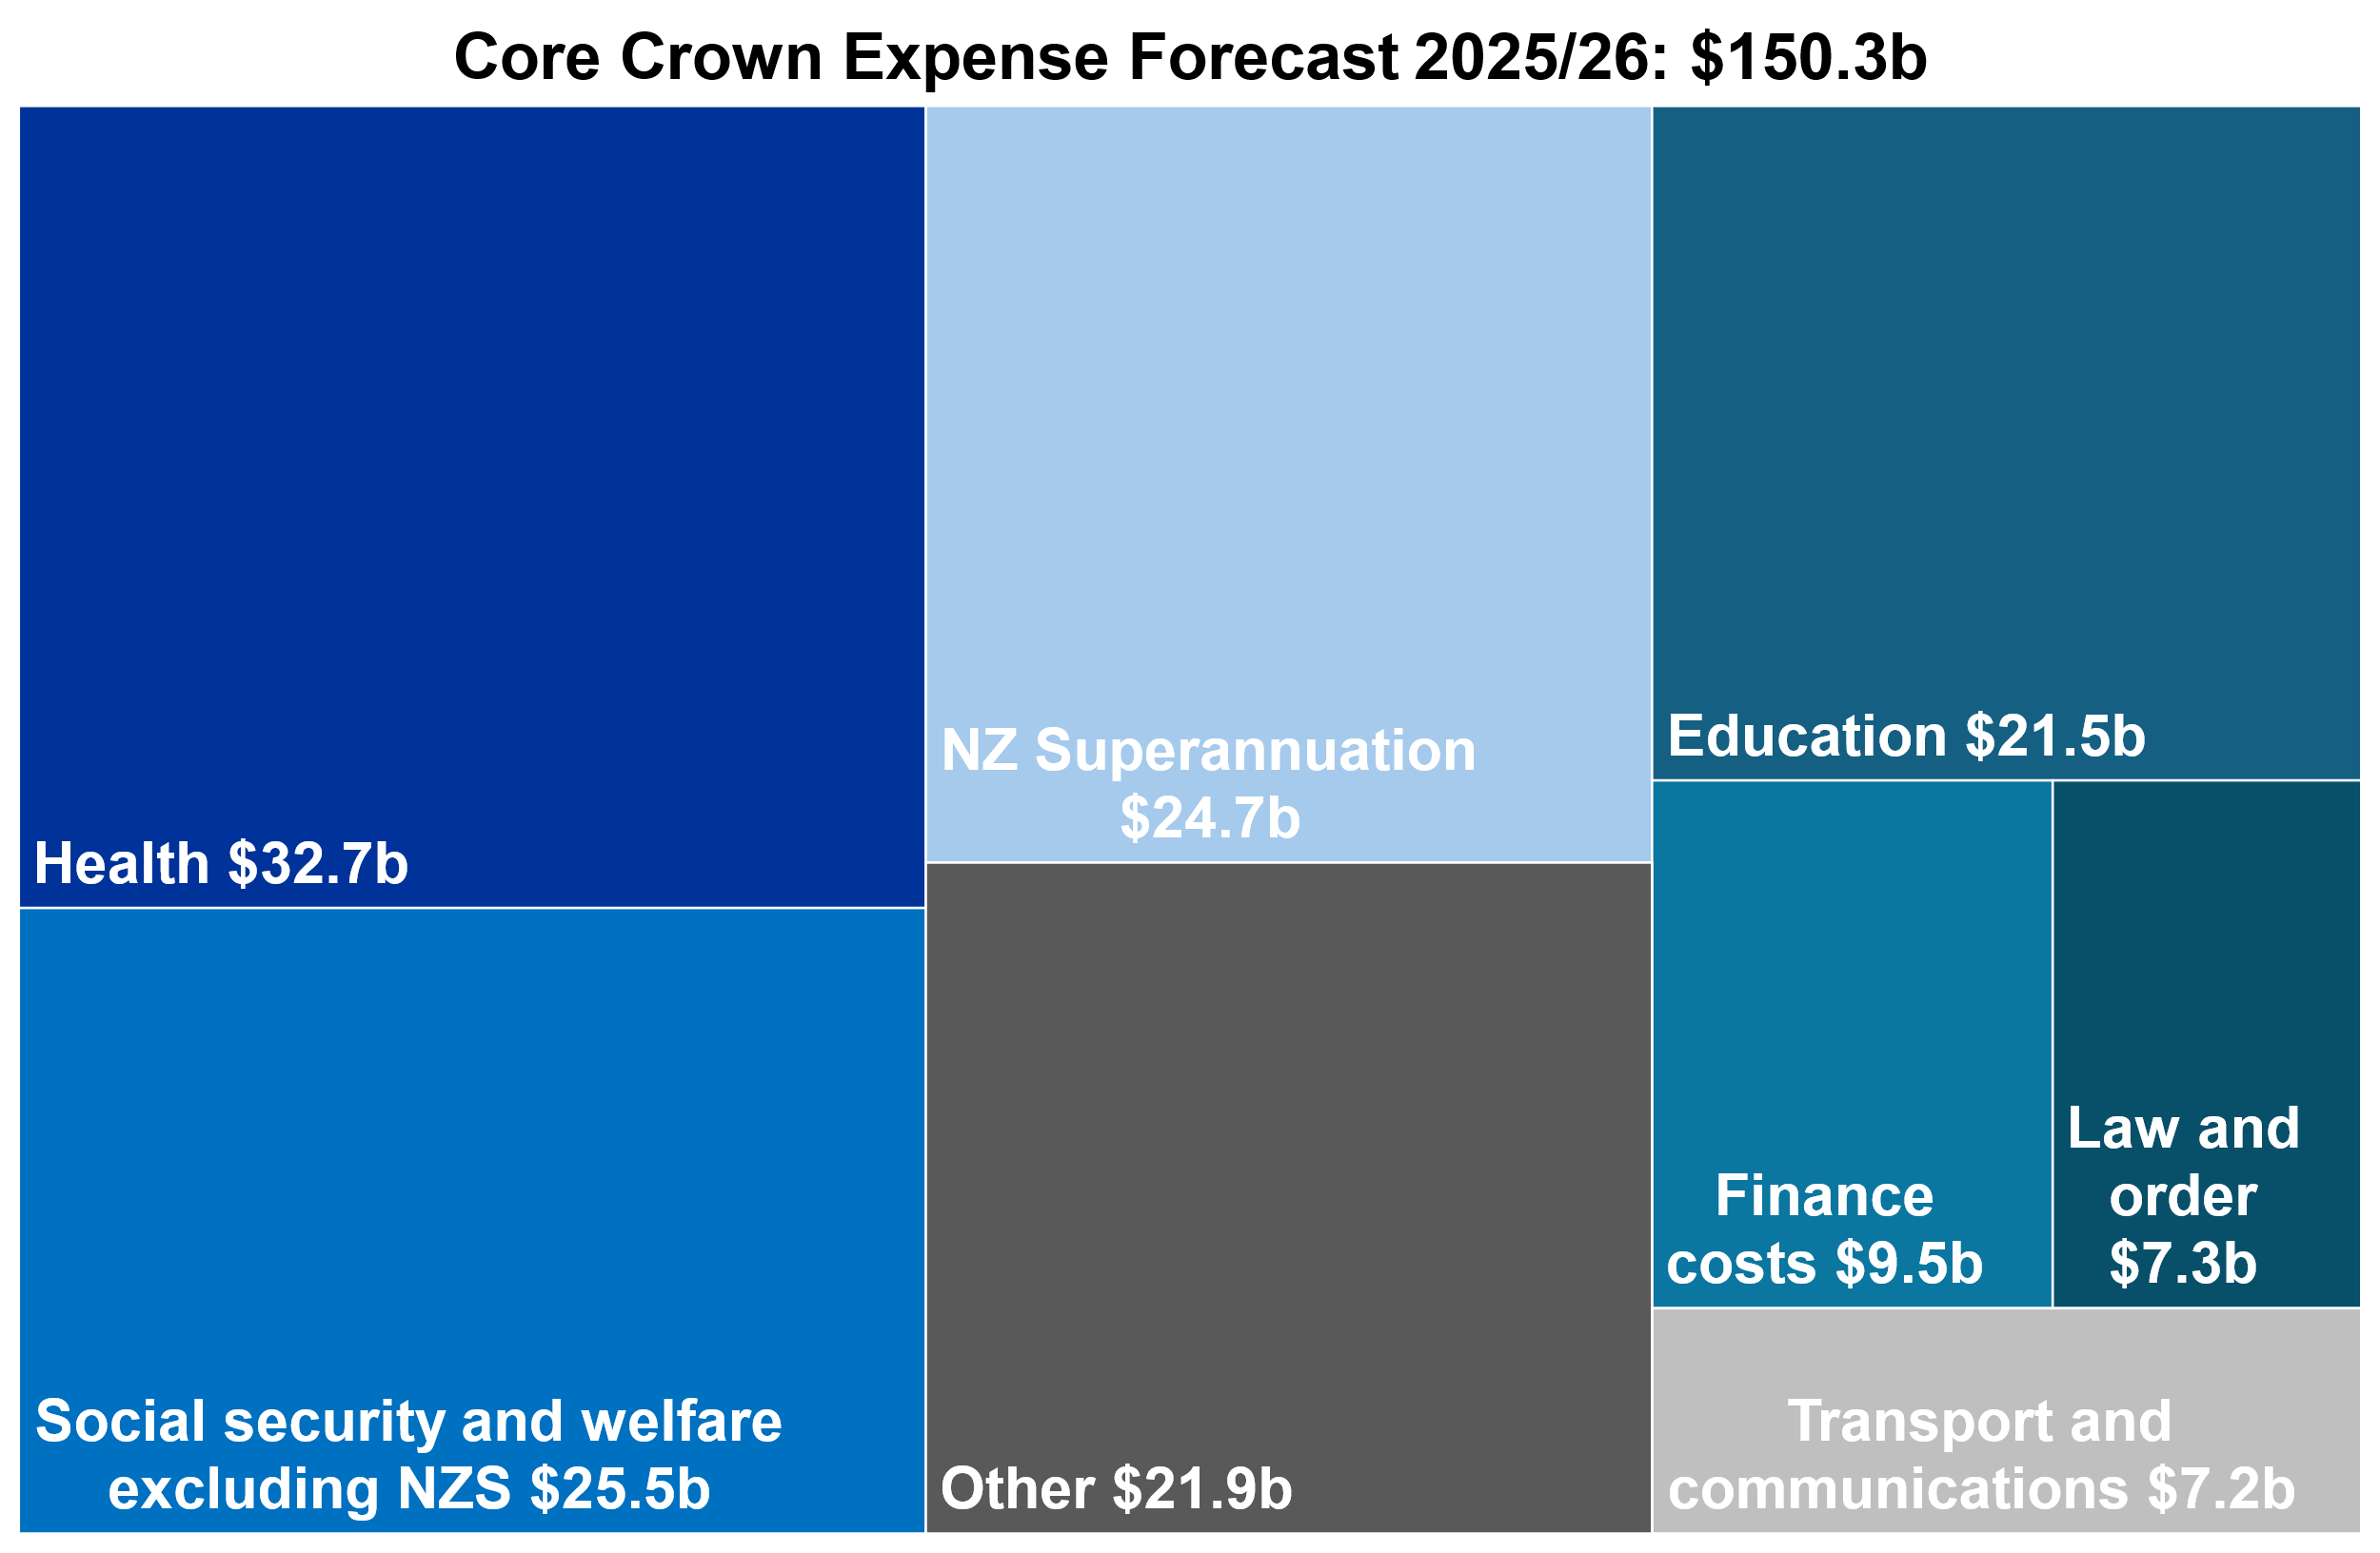

Permanent URL:   
[treasury.govt.nz/publications/glance/budget-glance-2025](https://treasury.govt.nz/publications/glance/budget-glance-2025)

Budget 2025 website URL: [budget.govt.nz/budget/2025/at-a-glance/](https://budget.govt.nz/budget/2025/at-a-glance/)



© Crown copyright

This work is licensed under the Creative Commons Attribution 4.0 International licence.